|  |  |  |  |
| --- | --- | --- | --- |
| **GREENS~LEAVES**    **Dunedin Vegetable Growers Club Newsletter**  **October 2020** | | **Meetings:** 2nd Monday of the month at 7pm  **Venue:** St Kilda Bowling Club,  33 Royal Crescent, St Kilda  **Membership:** Helen Flockton (455 1816) helen.flockton6@re.com  **Club Email:** [dvgcnz@gmail.com](mailto:dvgcnz@gmail.com)  **Website:** <http://dvgc.co.nz/>  **Bank Account #** 030905051590600  (Please include your name as a reference) | |
| **Next Club Meeting:** Monday, 12th October 2020  **Q & A:** David  **Club Talk:** Venue shift  **Guest Speaker:** Marion and Jo Thomas - ‘The Green Island Community Garden’  **Garden visit:** Tim Hyland,  Sunday, 25th October, 2 pm, only if at level 1. This is a suburban garden in the early stages of redevelopment into more food production. Plenty of parking available on the street. | | | |
|  | **Competition for October**  3 stalks of rhubarb | | **Things to look forward to in October**  Start of silverbeet growing competition  Garden visit |

Hello Everyone,

It is wonderful to have warmer weather and also be able to hold our club meetings again!

This newsletter gives suggestions what can be planted this month, introduces the possibility of a shift of venue and ask for ideas for talks, hosts for garden visits and help with suppers. There is an update on the planned Kindred Day.

**Garden tasks for October** - David

October is a busy time in the vegetable garden.

Time to sow seeds:

Asian vegetables, Asparagus, Beetroot, Sprouting Broccoli, Brussels Sprouts, Cabbage, Capsicum, Carrot, Cauliflower, Celery and Celeriac by mid-month, Courgettes, Cucumber, Kale, Kohlrabi, Leeks, Lettuce, Onion until mid-month, Parsnip (before November), Peas, Potatoes, Pumpkin-Marrow-Squash, Radish, Rhubarb, Salsify until mid-month, Silverbeet, Spinach, NZ Spinach after mid-month, Tomatoes and Turnip.

It is now too late to sow seeds of broad beans and last chance for Celery and Celeriac, Leeks, Onions, Parsnip and Salsify.

Time to plant seedlings:

Asian vegetables, Broad Beans, Cabbage, Cauliflower, Corn from mid-month, Courgette mid-month, Cucumber mid-month, Kale, Lettuce, Onions until end of month, Pumpkin - Marrow - Squash, Silverbeet, Tomatoes and Yams.

Last chance to plant: Onion sets.

It is now too late to plant: Jerusalem artichokes and Shallots.

Plan ahead for:

Capsicum plants – 1st Nov. Brussels sprouts plants – mid November. Green Sprouting broccoli plants – December.

**Sowing temperature guide** – supplied by Carol

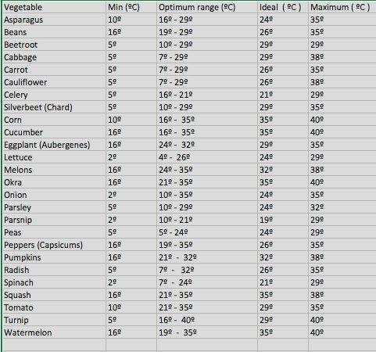

**Best Silverbeet competition** - plants will be available at this coming October club meeting.

**Information about shifting our venue –** DVGC committee

St Kilda Bowling Club: (our present venue)

• The bowlers disregard the timing of our meetings – consider it “their” space and bar

• Despite reminding them of our August meeting insisted we meet in another room

• Kitchen crockery needs cleaning before we can use it – we always leave it clean!

• Car park is insufficiently lit and has uneven surface that is dangerous in darkness

• Seating is not permanent and has to be reconfigured before and after each meeting

• Public address system does not allow ‘roving’ microphones

• Meeting area is becoming too small for us, especially if socially distancing

Caversham Baptist Church: (where we have midwinter dinners – in South Rd. Caversham

• We would have the meeting time entirely for ourselves

• There is a kitchen with a proven record of clean crockery

• Ample well-lit parking surrounding the church, mobility spaces and nearby bus stop

• Permanent comfortable seating and separate area for supper

• Modern public address system with a large TV for presentations

• Meeting area allows more than 200 people

• Less expensive

If we shift:

• We would change in January coinciding with our new membership year

• We would have to meet on a Wednesday – hence our survey

A shift will not suit everyone but we believe it will ultimately benefit the club.

We will discuss this at the October club meeting before making any decision.

**Kindred Day Update** – Helen Flockton

The Kindred Day committee met recently and after much discussion we have decided to cancel our Autumn Kindred Day 2021. There were many factors to consider but the main one was the uncertainty around Covid 19 and just where we will be in April next year. We have asked to defer our day till 2022 and are awaiting a reply from the convenor of the day to confirm this.

All non- perishable items will be kept by the club but if there is anything that you donated and would like returned please let us know.

**Opportunity for input into club program**

Clipboards will be circulated around at the October meeting, giving you the opportunity to suggest topics of interest for club talks and guest speakers, to offer your garden for us to visit and to volunteer your help with suppers.

**Calton Hill sales table** – Dennis Dorney

The first meeting of the season went well for the Calton Hill Sales table, selling all our 2L Lime containers and also our horse manure. Fresh stock will be available at the next meeting, of course. This means that I am now short of 2L milk bottles and welcome more. I would also like more useable 40L bags of the size sold by Mitre 10, Bunnings and the Warehouse. I find that I can get enough of these to standardise on them, which is convenient. Miscellaneous bags are a nuisance. I am particularly concerned about the number of wood pellet bags I am getting because I suspect that there is a vast quantity of them lying about in Dunedin, waiting for me to turn my back in an unguarded moment.

**Christmas Lunch** - date

Saturday, 5th December 12 30 pm, Mitchell’s Tavern, Caversham

