|  |  |  |  |
| --- | --- | --- | --- |
|  | | **GREENS~LEAVES**    **Dunedin Vegetable Growers Club Newsletter.**  **August 2019**  **Meetings:** 2nd Monday of the month at 7pm  **Venue:** St Kilda Bowling Club,  33 Royal Crescent, St Kilda  **Membership:** Helen Flockton (455 1816) helen.flockton6@gmail.com  **Club Email:** [dvgcnz@gmail.com](mailto:dvgcnz@gmail.com)  **Website:** <http://dvgc.co.nz/>  **Bank Account #** 030905051590600  (Please include your name as a reference) | |
| **Next Club Meeting:** Monday, 9th September 2019  **Q & A:** David  **Club Talk:** Protecting Seedlings  **Guest Speaker:** Stephen Dewdney, manager of YouthGrow  **Garden Visit:** Sunday, 22nd September 2013, 2 pm, Margaret Scott,  Meet at Bunnings carpark 1.20 pm for car-pooling. | | | |
|  | **Competition for September**  Any brassica  Winners of August competition:  Best leek, Allan Savell  Best parsnip, Ray Wade | | **Things to look forward to in September:**  Garden visit  Potato in a bucket start |

Hello Everyone

There is an exciting feel to the garden at this time of year: it is all about first sowings, raising and planting of seedlings – coddling them to make sure they are off to a good start and protected from the cold winds and dreaded late frosts.

Soils are the basis of healthy plants, so collecting, composting and/or spreading organic matter is an ongoing and most rewarding task.

**Potato in a bucket** – Ray Wade

To CHIT or not to CHIT : Sorry, but the selected Liseta early prolific cropping

seed spuds have been chitted and are ready for the annual spud in a bucket competition.

See Ray at the Sept trading table to get your seed spud and to register for the competition.

Plant in an 8litre plastic bucket in your own super secret soil concoction……then at the Dec meeting we have the much anticipated weigh in with kudos given for total crop, biggest spud etc. Remember Allan Savell’s experiments and results from last year!

**Garden Visit** in August – by Carol Henderson

Around 24 DVGC members and friends gathered at the Spottiswoode St address of Sue Novell and her husband Brian on a sunny Sunday afternoon, eager to see and hear all about it.

The park-like berm is tastefully planted with natives to absorb the runoff from the sloping section above and Sue introduced us to the native Mingimingi (Coprosma propinqua) by the gate which is covered with edible blue berries. Most of us had a taste, agreed they were quite sweet and would be refreshing if found during a bushwalk.

A few steps further on Sue pointed out one of her fig trees and explained her decision to put all of her fig trees into large pots to keep the roots from taking over the garden.

The walk up to the house took us past a huge magnolia and an established native forest on the left, then herb and flower garden borders amongst the orchard which led us up to the vegetables! At this point we all stood and admired the two huge espaliered fruit trees attached to the side of the two storey house....impressive!

Sue did a great job of explaining how her garden has evolved into a type of permaculture plot fed by the compost and it was amazing to see how much produce there was ready to pick now....including a huge spear of asparagus that Sue hadn't noticed but one of our members was very keen to pick!!

The idea of mixing up the few seeds of different types leftover and scattering them to allow a patch of mixed crop to develop was intriguing to many.

Afternoon tea arrived on the front porch with beetroot cake and a healthy slice enjoyed in the sun with the conversation of our fellow gardeners...mainly admiring such a wonderful garden, abundant food forest and it's creators!

Carol

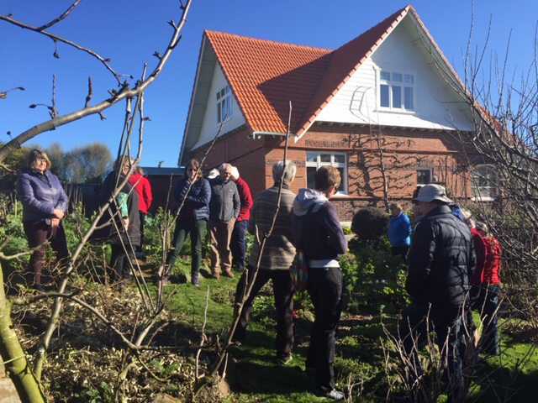

**Trading Table –** Dennis

Thanks to those members who have donated bags for horse manure. However, in future I will only be able to take the standard size 40 litre No 8 bags from Mitre 10 or the equivalent bags from Bunnings, Nicholls etc. This may sound petty but I fill the bags using a large shovel and I find that its blade is too big for smaller bags.

Also, I mentioned at the last meeting, that I had been given a biggish quantity of Epsom salts to sell on our Community table. At the next meeting I shall have about 10 1Litre plastic bottles for sale at $2/ each plus a few small containers that people can try for free.

Epsom salts is Magnesium Sulphate in crystallised hydrated form, so it dissolves very quickly. It is pH neutral and its supporters say it is great for tomatoes, capsicum and fruit trees. Not everyone agrees with that.

The info below came from USA measurements on Google, so are approx:

Used as crystals, sprinkle about 1 tablespoon direct into the holes that have been dug for the plants and back fill.

Used with a 10 Litre watering can, use one of a small measuring scoop of the kind found in washing powder boxes and drench the leaves.

**Heritage Roses** - Fran Rawling (Convenor Roses Otago)

Celebration of the return of the heritage roses to the Dunedin Northern Cemetery at the Sextons Cottage, Northern Cemetery, Dunedin

7th & 8th December 2019, 10:00am – 5:00pm, free entry, tours and presentations.

**Kindred Day** – Margaret Scott

Hi,

Really getting into the planning now, and if you put your name down to help, you may get a call. Say yes, or no, depending on if the job suits you. We are going to rely on the support of club members.

How is the potting up of plants going? The sale of the plants will help fund the day.

Think about coming to the October Kindred day in Kakanui.

Marg

