History:  Sweetcorn was cultivated by the native Indians tribes long before the first European settlers arrived in American. Even back then there where varieties that were sweeter than others and it of these that out modern sweetcorn varieties have been developed. | Sweetcorn  Zea mays | Cultivation:  - As the plants are wind pollinated they should be grown in blocks rather than rows, 30-60 cm.  - Corn is a heavy feeder so ensure a well worked bed with plenty of nutrients added prior to sowing / planting.  - Soil must be keep consistently moist to produce fat juicy cobs, esp. when cobs have developed. Thick heavy mulch is essential. I use a seaweed, sheep poo and pea straw combo.  - Like tomatoes, corn produces aerial or stem roots. If these can be fed as well (via heavy mulching), the crop yield will be greater.  - Perform acts of nature by periodically tapping the tops of the plants (male flowers) to increase your pollination rate(s).  - Maintain a regular feeding schedule once the cobs start to form. Side dress with blood n bone, liquid feed with something amazing. Whatever you choose, just keep it up at regular intervals.  - Ripeness / readiness is measured by the silk tassel ends withering and turning choc brown.  - Protect from and keep an eye out for: slugs / snails, wireworm, aphids, earwigs and the corn earworm (sounds delightful…) Treat accordingly.  - Remember, CROP ROTARTION!
Varieties of today:  Heirloom  - Stowells Evergreen  - Country Gentleman – White grained.  These produce sweet milky pale yellow to white kernels in an irregular zigzag rather than rows like modern sweetcorn.  - Silver Queen  One of the best late-season white sweetcorn varieties. It grows to 2m and produces large 20-30cm plump cobs.  - Golden Bantam  Another old variety. First introduced in 1902, it will grow to 1.5m and produce compact 12-17cm cobs that are mildly sweet.  - Many more available at http://www.koanga.org.nz/  Modern / Hybrids  - Florida Super Sweet  Grown as the main summer commercial crop, provides from excellent storage whilst maintaining crispness.  - Honey and Pearl  Has essentially pushed all others from mainstream nurseries and big box retailers. Most common. | 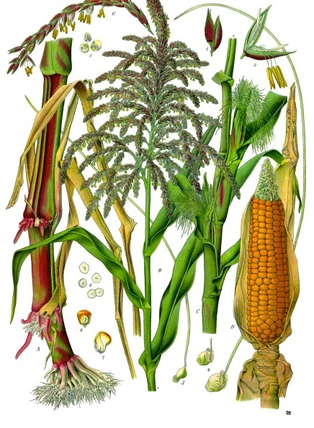
 | Tips from various sources:  - Eat freshly picked, within one hour of harvesting. Beyond this the sugars (sweetness) begins its transformation into starch.  - Provide shelter from the wind! Esp. when young.  - Protect from earwig invasion.  - If sowing direct, opt for a fungicide treated seed, otherwise hold off until later on in season. Cool moist wet soil can cause seed to rot soon after sowing. In this situation start in seed trays.  - Start with a mini variety if you haven’t grown before, they tend to be easier. | Three sisters:  An old form of companion planting. Sweetcorn, beans and squash. Mix it up with the use of different varieties and add a nasturtium or marigold.  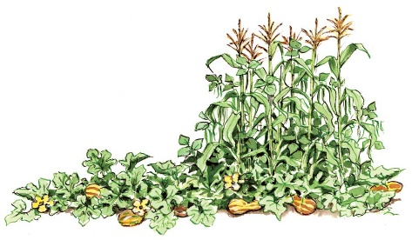  The corn supports the beans, the beans add nitrogen and the squash shades out the weeds.

