GREENS~LEAVES

**Dunedin Vegetable Growers Club Newsletter; issued monthly, Vol10:5 May 2017**

**Next meeting; 7pm, Monday 10th April**

**Venue is the St Kilda Bowling Club, 33 Royal Crescent**

Past President*;* Carol Henderson (454 4625) hendersonic@xtra.co.nz

Membership: Heather Wilson (4764607) heatherandmike@clear.net.nz

Website ; http://www.dvgc.co.nz/

**Monday 8 May**: Welcome and notices Remember to bring your favourite garden hand tool **Club Talk** – Sarah Fenwick on Garlic **Planting now/Q&A** - David **Competition:** Silverbeet in a bucket **Main Event –** Members show and tell - Our favourite gardening hand tools **Garden Visit:** Heather and Mike’s garden May **Supper** – Thank you to Joy and to those who have signed up as supper volunteers 😊 Midwinter Dinner June 17th 6pm for 6.30pm start

**May…..**

…..and, as I type this, it is raining outside with snow forecast to 500m….no summer and early winter? I’m still harvesting chilli and pears while the crop of Feijoa still to come are growing bigger with the rain.

The committee are grateful for your support with ideas and suggestions for topics…thanks to Ian and Jule Norris for arranging the SEED; the movie viewing😊

**Awesome April Meeting**

Rye Senjens talk on Glyphosate was very informative and we all appreciate having the slides for future reference.

Diana Noonan surprised us all by producing a large percentage of her household’s diet in her small garden and then shocked us by describing lengths she had to go to protecting her crops from the wildlife and the weather!!

A couple of very thought-provoking presentations…

David on Q & A always promotes some interesting discussion with great input from members.

Thanks also to Dennis for keeping the trading table ticking along even in the colder months.

**Competition winners**

Diana Noonan chose Ray Wades’ rhubarb and Florence Fennel

Club members chose Mary Thompsons’ grapes and Marg. Scott’s (giant) pumpkin

Congratulations!!

***Garden Visit to Alan Savell’s***

***Garden visit to Alan Savell’s***

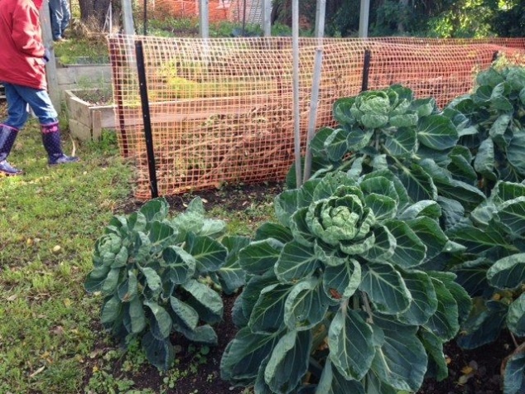  
The weather was not promising for the garden visit to Alan Savell's garden on April 30th and yet 16 of us made our way up the very steep hill... only 3 of us in a car!!

The weather settled down as we admired the panoramic view from the City to St.Clair. Then we admired Alan's bumper crops of Brussel Sprouts, Leeks and Silver beet and Beetroot at our feet (the lawn is above the garden).

After wondering at the number of pears on the 100 year old pear tree we did the rest of tour trying not to step on the myriad of pears on the ground.

Alan has done a great job of building up the soil with compost and seaweed so that everything grows well... including an amazing reproducing cauliflower which, after the initial cauliflower was cut, went on to form another 4 all by itself !!  
Alan's enthusiasm included a warm and welcome afternoon tea by the fire and we all left feeling very glad we had braved the weather 😊

Midwinter Dinner is on June 17th

6pm for 6.30pm start

Venue; the Caversham Baptist Church on the corner of South Rd and Surrey Streets. One block South from the Challenge garage.

Please bring a Dessert and a Main dish (can be soup). There will be a separate table for gluten free, vegetarian etc. and we request that a recipe or confirmation of lack of gluten, meat, dairy etc. be placed by these dishes.

😀**GARDEN TASKS FOR May 2017**

Continue to mound up celery and leeks if you do this. Harvest your seeds and sow greencrop to dig in later.

Sow seeds of Broad beans and plant seedlings of Sliverbeet and Brassicas.

Plant garlic and shallots from now until June.

**Moon Planting April 2017**

May 1st to 9th –sow and plant above the ground crops

8th and 9th – good time to give your plants some liquid fertiliser.

29th to 31st…sow more broad beans.

**BUY, SELL AND SWAP** Nothing in from members but I do have fig cuttings bits to be dug out in May/June as they are getting too big.

Contact 03 4892030 msscott@xtra.co.nz

**Please bring in your spare garlic or shallots to share and/or swap**

**Membership Subs Due**

If you haven’t paid it has gone up to

$15 for non postal , $20 for postal memberships.

**Bank** **Account details**…For those who would like to pay their subs via internet banking the Club bank account number is; Westpac 030905 0515906 00 Please remember to add ***your name*** as reference when paying by internet banking :)

**May meeting**

*Club talk:* Sarah on Garlic

*Competition:* Silver beet in a bucket

*Speakers*: Members on Favourite tools and caring for them.

**August meeting**

Club Talk ; Safety in the garden

Speakers; Seed swap evening Competition; one Parsnip and/or one Leek

**Calling all gardeners!**

Diana Noonan writes a “Things I wish I’d known earlier” column in Kiwigardener magazine. If you have any gardening tips or knowledge that you wish you had known earlier in your gardening career, she would love to hear of them.

Diana can be contacted at ;

[papatowainz@gmail.com](mailto:papatowainz@gmail.com)

Feel free to offer as many tips as you like**.**

**Horseradish Sauce** (from Classic Preserves)

Ingredients;

45ml/3 Tbsp horseradish root

15 ml/ 1 Tbsp white wine vinegar

5ml/1tsp sugar

pinch of salt

150ml thick double cream (crème fraiche is good)

Peel the Horseradish root and then grate it finely (a microplane is excellent for this)

Horseradish is a very powerful ingredient so take care to keep the root under water while you peel it.

Place the Horseradish in a bowl and wash your hands. Add the white wine vinegar to the bowl along with the sugar and just a pinch of salt. Stir ingredients together until thoroughly combined.

Pour mixture into a sterilised jar. It will keep in the fridge for up to 6 months. A few hours before serving stir in the in the cream and leave it to infuse.

I made a seventh of both the horseradish and the cream amounts when I wanted to use it and that worked really well.

Thanks for taking the time to read this. If you ever want to write something about your garden, or growing edibles, contact me;

Marg Scott; [msscott@xtra.co.nz](mailto:msscott@xtra.co.nz) or 4892030