GREENS~LEAVES

**Dunedin Vegetable Growers Club Newsletter; issued monthly, Vol10:4 April 2017**

**Next meeting; 7pm, Monday 10th April**

**Venue is the St Kilda Bowling Club, 33 Royal Crescent**

Immediate Past President*;* Carol Henderson (454 4625) hendersonic@xtra.co.nz

Membership: Heather Wilson (4764607) heatherandmike@clear.net.nz

Website ; http://www.dvgc.co.nz/

**Monday 10 April**: Welcome and notices **Club Talk** – Rye Senjens speaking on Round up and some alternatives **Planting now/Q&A** - David Competition Personal best Fruit and or Vegetable **Guest Speaker-** Dianna Noonan on Living off the land. Growing vegetables to be as self - sufficient as possible **Garden Visit:** Alan Savells’ garden on Sunday 30th April at 2pm, Please walk up the driveway which is quite steep! **Supper** – Thank you for those who signed the board last month We will be putting it around again this month as we need more names who signed the board last month We will be putting it around again this month as we need more names

**Margaret Scott**

April, and daylight saving so winter is on the way. Some nice April weather we hope to finish ripening the pumpkins and tomatoes. How are peoples silver beet plants growing in their buckets for the competition in May. Mine is very slow. I would be interested if anyone else is growing the beans from Heritage food Crops research. This year I am hoping for the experimental beans to dry as I grew three. I grew Good Mother Stallad, Peruvian Goose, Prices Cherokee as well as Butterfly Beans and Borlotti. Borlotti crop doing well and Peruvian goose has a great crop. If others are interested we could have a taste testing of some sort.

(I had fresh Borlotti last night for dinner)

**March Meeting**

I loved the talk by Ross and Sarah on saving tomato seeds. I hope a few of us try both methods. Thanks guys 😊

The competition was won by Ross for the Heritage tomato and we think David for the Hybrid which was called ‘Ace’ but no name for the competitor!! The panel on perennial vegetables seemed to go OK.

It would be great if people brought some of the plants in potted up. Joys Magic onions I sure over time will share around the club.

Great supper and David on Q & A always promotes some discussion.

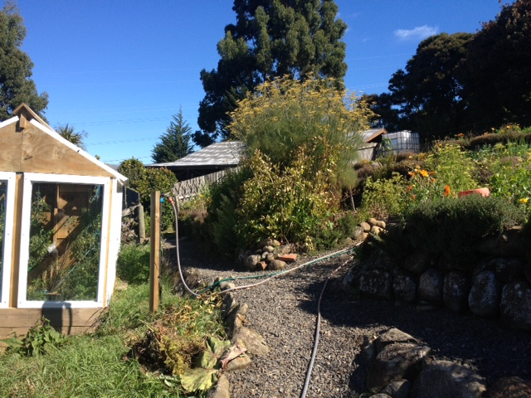

***To Jan and Marloes***

Thank you for your garden visit.

A garden up a steep difficult road, but when you reach it, all of Dunedin is stretched out in front of you. We were welcomed into the garden by a wwoofer gently playing a guitar, excellent views, a very productive garden, convivial hosts and amazing Fruit based pies (accompanied by a glass of cider), for afternoon tea – bliss!

Large vegetable plots meandering up the slope, two areas of fruit trees, sheep in the paddock and an amazingly solid, well-built glass house made from hardwood windows, recycled from a nearby school made for a lifestyle to be envied. A wonderful garden visit enjoyed by all who visited.

***Lynne***

**GARDEN TASKS FOR April 2017**

Mound up celery and leeks if you do this. Harvest your seeds, Sow seeds of Broad Beans Plant seedlings of:

Lettuces (winter) silver beet, spinach, and Spring onions.

All brassica’s; although getting later Broccoli, Brussels sprouts, Cabbages, Cauliflower, Kohl Rabi, Kale also Spinach and Silver beet. Asian greens are faster growing at this time of the year than some other brassica’s.

Sort garlic and shallots for planting from May, Seed swapping …Usually at the August meeting and again this year BUT the committee thought we could try seeing if anyone had extra garlic and or shallots to share at the May meeting

**Moon Planting April 2017**

April 1st to 7th –sow and plant above the ground

22nd and 23rd – root planting Getting ready for Garlic and Shallots.

**June 17th 6pm**

We have booked the church hall for

Midwinter dinner in June. More details later. Has anyone got an idea for speakers….?

Good with your tools??? We are planning on looking at systems for looking after your tools. Any tips or volunteers???

BUY, SELL AND SWAP Nothing in from members but I do have fig cuttings bits to be dug out in May/June as they are getting too big.

Contact 03 4892030 msscott@xtra.co.nz

Membership Subs Due If you haven’t paid it has gone up to $15 for non postal and $20 for postal Bank Account details…For those who would like to pay their subs via internet banking the Club bank account number is; Westpac 030905 0515906 00 Please remember to add your name as reference when paying by internet banking :)

**May meeting**

*Club talk:* Sarah on Garlic

*Competition:* Silver beet in a bucket

*Speakers*: Panel on Favourite tools and caring for them.

**Cranberry Upside Down Cake**

Ingredients;

Fresh cranberries -350-400 g / 12-14oz/ 3-3.5 cups

butter-50g/20z/1/4 c

caster sugar(superfine) -150g/5oz/1/4 c

**For the Cake Mix**

plain all purpose flour- 65g/2.5 oz/9 Tbsp

5ml/1 tsp baking powder

3 eggs

Sugar-115g/4oz/generous1/2 c

Grated rind of one orange

butter melted-40g/11/2oz/3Tbsp

Preheat oven to 180oC/350oF/gas4 and place a baking sheet on the middle shelf of the oven. Wash and pat dry the cranberries and thickly smear the butter on the bottom and sides of a 23x5cm/9x2” round cake tin.

Add the sugar and swirl the pan to coat evenly. Add the cranberries and spread in an even layer over the bottom of the pan.

For the cake mixture, stir the flour and baking powder twice and set aside .

Combine the eggs, sugar, and orange rind in a heatproof bowl and set over a pan of hot but not boiling water. With an electric mixer, beat until the eggs leave a ribbon trail when the beaters are lifted. ( I think this is the trick of the cake I started with boiling water and you have to beat for a while and the mixture trebles in size. The ribbon is because it is getting thicker)

Add the flour mix in three batches, folding in well after each addition. Gently fold in the melted butter and then pour the mix over the cranberries. Bake for 40 mins. Leave to cool for 5 minutes, then run a knife around the edge to loosen. While the cake is still warm, invert a plate on top of the tin. Protecting your hands with oven gloves, hold the plate firmly and tip firmly and turn them both over quickly. Lift the tin off carefully.

Thanks for taking the time to read this. If you ever want to write something about your garden or….. Contact me Marg Scott msscott@xtra.co.nz 489 2030