GREENS~LEAVES

|  |
| --- |
| **Dunedin Vegetable Growers Club Newsletter; issued monthly, Vol: 9: Sept 2016**  **Next meeting; 7pm, Monday 12th Sept**  **Venue is the St Kilda Bowling Club, 33 Royal Crescent**  Immediate Past President*;* Carol Henderson (454 4625) hendersonic@xtra.co.nz  Membership:Heather Wilson (4764607) heatherandmike@clear.net.nz  Website ;<http://www.dvgc.co.nz/> |

**Monday 12th Sept:** Welcome and notices   
 **Vegetable of the Month -** Sarah on all things corn including the three sisters method of planting

# Planting now/Q&A - David

**Club Talk/Speakers -** Louis Brown on The Whare Project.

**Competition** – Any brassica

**Garden visit** – Sept 18th  Stephen and Barbara McCabe’s at 2pm 122 Campbell’s RD, Pine Hill   
 Meet in Strathallan Street outside Bunnings car park.

Wow warm and then cold **--**so just a usual spring. The planting season has started though as things are starting to grow. The first spring bulbs are out and self-sown crops are doing well.

It is so exciting planning where all the plants are going this season. Each year I tell myself the crop rotation will be organised. I have visions of sticks with numbers on them for each bed so I do not forget (again). where I want to put things and plant something else by mistake that does not like the plant beside it.

**August Meeting**

Thankyou everyone for the seeds bought in to swap.

The competition of preserves the winner was Clair Hewson for sweet ***and*** savoury with her delightful Raspberry jam and Hot Mustard Pickle

The distribution of the seed potatoes and buckets (gold coin donation) for the December competition is still available for this month. Thanks to Sarah who took them home last month and chitted the potatoes for those who did not get them at the August meeting.

Margaret spoke briefly on saving seeds.

The garden visit was to Ross’s garden and he had lots of healthy looking brassicas and a delightful space for planting under the house. There was a group of about 15 of us

Ross’s Garden - some of it. Loved the Feijoas up the back.

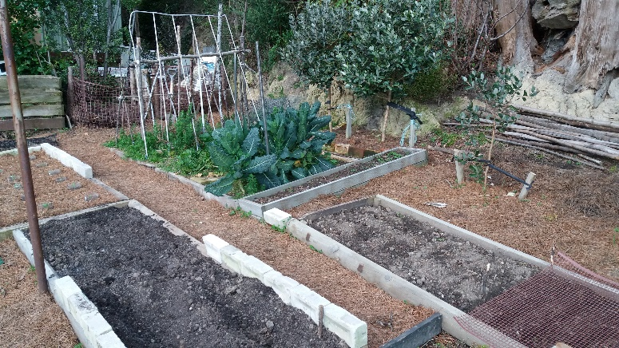

**Syrian Refugees.** Jim did a call for old tools for the garden to help the refugee families. Anything else for the garden would also be useful. There are about 30 families in the Dunedin area and although they do not all want to garden many do. One of the families in Mosgiel has already received a spade and fork and (Thanks to Carolyn from the club a wheel barrow) and half the back yard is dug over. They will also need plants herbs and soft fruit etc. The Red Cross are creating a list of plants they know and want. But if you have plants you can pot up, please do so. Also if anyone is OK for a few families visiting their garden to have a look let me know. This may or may not happen. The Red Cross is also looking at a person acting as a support person for a family in their local area to look at what to grow locally. Have a think about this idea as well.

**September Meeting**

I am looking forward to our speaker this month it is Louis Brown who has set up a project of growing his own food and fruit in 100 square metres of garden.

Sarah is talking on all things corn and the three sisters way of planting.

The garden visit is on Saturday 15th Oct, 2pm, to Stephen McCabe’s garden at 122 Campbell’s Road, Pine Hill. Car-pooling at the south side of the car parks on Strathallan Street. Meeting at 1.35pm at Bunnings.

Buckets will be available again for potato in the bucket competition in Dec and more potatoes if you missed one last meeting

# I am looking forward to the competition of any brassica this month just to see what people do have ready.

David will do the Q&A and planting now session as well this month

**Up coming events**

Mornington Spring Picnic.

Jubilee Park Mornington

The vegetable club will be having a stall there to promote vegetable growing. We welcome volunteers between 10 and 2 if you have a spare hour let Carol or Margaret know. The focus is on food diversity.

Elizabeth Whitcombs from the Alpine Club

The Otago Alpine Garden Group holds its Spring Show 2016 on October 1-2 at St Peter’s Church Hall, Hillside Road. I would like to contribute to our raffle a box/basket of veg plants from Veg Growers table, with Dn Veg Growers’ Club + website to be prominently displayed on the box.

The Horticultural Society Spring show is on the 24th and 25th of September. Ring Susan Bagley 4884054 if you are interested in knowing more and you would like to enter the competition for vege’s and flowers

# Membership badges (another reminder as we do not do accounts)

Some of you have been wondering what the

Coloured stars are on your membership badges and

it is very simple;

Red star that means you have paid 2016 subs. If you have a green star then you *did* pay in 2015 but have not paid for 2016 yet ☺

**Bank Account details…For those who would like to pay Their subs via internet banking the Club bank account number is; Westpac 030905 0515906 00 Please remember to add your**

**name as reference when paying by internet banking :)**

**GARDEN TASKS FOR SEPTEMBER 2016  
For our beginner’s garden using low demand vegetables that produce a crop when conditions are not good:  
ie:** Beetroot, broad beans, carrot, kale, leaf lettuce (in rich soil), parsnip, peas and silverbeet.

**Time to plant:** Broad beans, leaf lettuce and silver beet.  
**Time to sow:** Beetroot, broad beans, (this is the last month), carrot, leaf lettuce, parsnip, peas and silver beet.

**For more experienced gardeners.**

**Too late to plant:** Asparagus plants and Garlic bulbs but could plant Shallots.

**Last chance to plant:** Jerusalem artichokes and Shallots.

**Time to plant:** Asian vegetables, Broccoli, Cabbage, Cauliflower, Onions and Yams.  
**Time to sow seeds:** Globe artichokes, Asian vegetables, Asparagus, Brussels Sprouts, Cabbage, Cauliflower, Celery and Celeriac, Courgettes, Onion, Potatoes, Pumpkin-Marrow-Squash, Radish, Rhubarb, Salsify, Shallots, Tomatoes & Turnip.  
**And after the middle of the month:** French, Runner and Butter beans, Capsicum, Corn, Cucumber, Fennel and Spinach.

Also if you have a warm spot chilies and tomatoes

***Moon Planting September 2016***

**September 4th to 13th** –sow and plant above the ground

**19th and 20th**– root planting

**26th and 27th** - root planting

**October 4th to 13th –** sow above ground crops

# Sales Table

PLEASE PLEASE PLEASE consider potting up your extra seedlings and **label them** for the sales table, or even sowing some extra on purpose!! Carol is away for the next two meetings and regrets not being able to do seedlings as usual.

However, there will be a couple of trays of Merveille de Quatre saison (4 seasons) lettuce, a few herbs and some rhubarb divisions so far☺

**Library Book** We are missing the Astrological Gardening Book that has been borrowed without being written in “ the borrowing book” If you have this could you please return it. Thanks.