|  |  |  |  |
| --- | --- | --- | --- |
| **GREENS~LEAVES**    **Dunedin Vegetable Growers Club Newsletter**  **May 2022** | | **Meetings: 1st Wednesday** of the month, 7pm  **Venue:** Caversham Baptist Church,  239 South Road, Caversham  (Corner of Surrey St. and South Rd)  **Membership:** Helen Flockton (455 1816) helen.flockton6@gmail.com  **Club Email:** [dvgcnz@gmail.com](mailto:dvgcnz@gmail.com)  **Website:** <http://dvgc.co.nz/>  **Bank Account #** 030905051590600  (Please include your name as a reference) | |
| **The May club meeting is cancelled. We very much look forward to our Midwinter Dinner in July.** | | | |
|  | A big shout out to all who pass on their skills, cuttings, seedlings and seeds to novice gardeners in their community! | | **Things to look forward to in May**  Some time to nourish our soils and souls after a busy harvest season |

Hello everyone,

In this newsletter you can find our May growing guide and a detailed report on the April garden visit. We have an article on restoring our soils in Autumn - with relevant video links. Also ideas on garden planning for diversity and succession of plants and a recipe for a hearty soup. We remind members to pay any outstanding subs and call for supper organiser/s at future meetings.

**Garden tasks for May** - by David

Last chance to plant:

Seedlings of kale and silver beet

Still a bit of time to sow:

Pea seeds until the middle of May.

Broad bean seeds until the end of May – plant by Anzac Day for Christmas

Still a little bit of time to plant:

Asian Vegetable seeds (until end of May)

Plenty of time left for:

Seedlings of Cabbage (until the end of June).

For a well laid out Southern Hemisphere sowing and task guide by renowned British gardener Charles Dowding, applicable to our cooler climatic conditions, click [**here**](https://charlesdowding.co.uk/wp-content/uploads/2018/12/Southern-Hemisphere-Sowing-Guide-2022.pdf)

**Report on our visit to the Green Island Community Garden** – by Sue

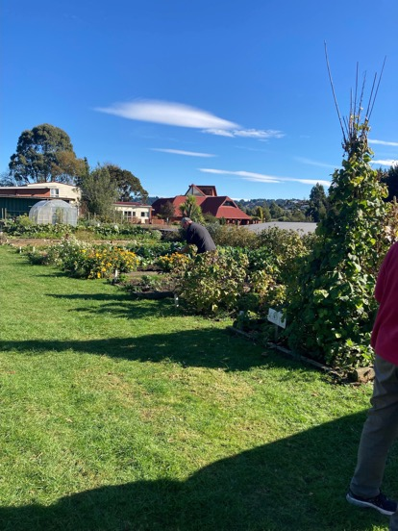A glorious Autumn morning set the scene for an enjoyable tour of the thriving Green Island Community Garden, managed by Marion and Joe Thomas. The sun drenched terrace, originally an old rail corridor, now belonging to the local church, had been a sheep paddock six years ago. Now it boasts an impressive line up of lush vegetable beds and young fruit trees, berry bushes, a herbery, various sheds and a tunnel house, a composting area with a large potato and also a pumpkin patch.

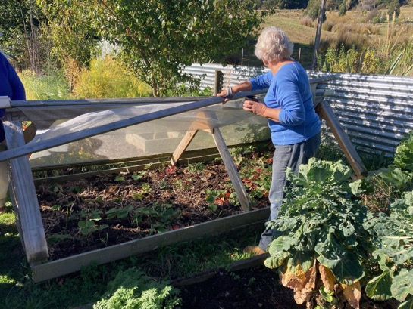There is a strawberry bed with an ingenious lift up cover for bird protection, a big tepee for runner beans and a compact chicken tractor made to fit over beds that periodically need clearing out of spent greenery. The Mens Shed next door adds to the perfect set up with access to a handy skill base.

The community gardeners group has fluctuated in numbers over the years, but now has 15 strong workers who mainly grow for themselves. Surplus produce is dropped off at a community stall and given to community members in need. There are generally no vegetable and fruit sales on site.

The garden is run organically, without artificial fertilizers and insecticides, using compost from piles built with horse and cow manure, grass clipping, leaves and ‘good’ weeds (‘bad’ weeds go in a separate pile). Unsprayed woody material is brought in by a contractor. Judging by the lushness and health of the plants, the compost is very effective in nourishing soil life and holding moisture. Plants are only watered to nurture them at the start, then left to the elements. There are no sprinklers. Handwatering only happens when really necessary.

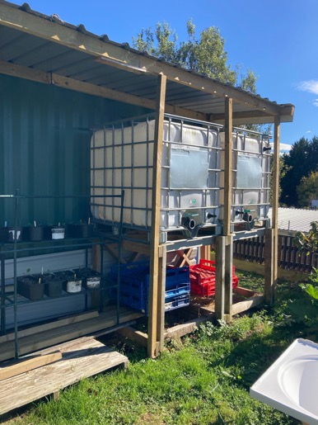Water is metered; so this year a lot of work is going into setting up extensive rain water harvesting and storage systems (5000lt) using sheds on site.

The garden has been funded through local grants, donations and fund raising at local markets. Groups of school children and intellectually disabled community members regularly spend time in the garden.

In this perfect setting birds and insects thrive on fruit, nectar and seeds. One has to be quick to get the plums before the birds. Flowers of calendula, phacelia, chamomile and borage lace the bed edges and attract lots of bees from the bee hives nearby. Peas were unfortunately decimated by birds and rabbits this year. Yams are kept in check in an old bathtub. On a sunny northfacing wall the loganberries have fruited the best ever, with large plump fruit, without additional watering.

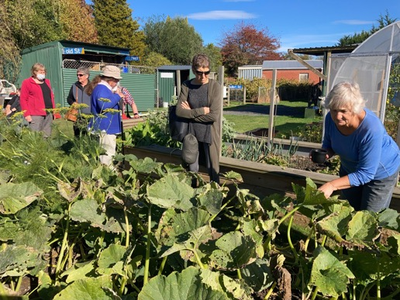The opposite side of the garden is edged with a long berry hedge: currants, gooseberries, feijoas etc. In between is the row of vegetable beds with a blood peach and plum tree to the side. There is a mixed onion and perpetual maori potato bed, a newly planted white and red broad bean bed (with wind shelter), the spent brassica bed with the chook tractor over it, rhubarb and sparagus bed, tall runner bean tepee, a bed of still small leeks, kale, brusselsprouts (did not do well in Summer, they would grow them over Winter next time), a bed of Pak Choy, three lots of carrots sown in September, November and January respectively, zucchini and spaghetti marrows grown in tyres inbetween young fruit trees (they plan to grow them in piles of compost in the open ground next year), a bed of parsnips sown in late October, as the first sowing did not take. Huge self sown grey crown pumpkins sprawl in a large bed, beside a raised no-bending bed for salad greens. The new tunnelhouse is still full of various sized tomatoes and when emptied will have screened compost added for mesclun and other Winter greens.

Further up the slope lies the large potato patch where potatoes have been grown in successive years. The potatoes were all harvested together, and sold as fundraiser for new good quality seed potatoes. To avoid problems with scab, every potato is nestled into a handful of pine needles to acidify the soil. In between the harvests a covercrop of oats and mustard with nasturtium seedlings gets dug in.

The orchard is situated on church and council land, along the old rail corridor, and is slowly added to with donated money. Nut trees, walnut and hazelnut, are next on the list.

It is very inspiring to see the projects done and progress made in this garden, a real asset to community resilience and education.

Many thanks for your hospitality, Marion and Joe.

**Worm farm building workshop** – build your own worm farm

Saturday 7th May, 10 am, Green Island Community Garden, koha to garden

**Planning for year round succession of produce** -by Sue

Being able to harvest a continual succession of food from the garden is a challenge. Our garden is North facing and gets quite a bit of sun in Winter, so it should be possible. Over the course of the year I took note of the variety and amount of food that I am able to pick at any given time: Is there a spell with few fruit available or a lack of vegetables? Do I need to fill any gaps in my harvesting calender? I also want to avoid having gluts of produce, unless I can store it easily (dried, bottled, frozen) for the lean times, or if I want to donate it.

Now in Autumn I plan to shift plants that are not in the right place and to propagate and acquire ones to fill the gaps. I collect seeds, order fruit trees, take cuttings of herbs and berry bushes, spread strawberry plants and seedlings etc. Flowering plants and seeds for insects and birds are also desired all year round.

Looking for inspiration I found this video that teaches about guilds and functions of plants - how best to group them to increase health and fertility, click [here](https://youtu.be/XLPUN2wGbwA)

**Restoring our Soils** – by Sue

Soil and Carbon

According to a [2019 UN Environment Report](https://wedocs.unep.org/bitstream/handle/20.500.11822/28453/Foresight013.pdf?sequence=1&isAllowed=y&mc_cid=211e03729d&mc_eid=854cadb1f1), "a third of the CO2 emitted through human activities into the atmosphere from 1850 to 1998 came from agricultural activities."

And, equally alarming, modern agricultural practices are responsible for soil erosion so catastrophic that if continued, we can expect to lose all of the Earth's topsoil in less than 60 years.

*"Twenty-four billion tonnes of fertile topsoil extending to 12 million hectares are lost every year. This is equivalent to a land area almost the size of Greece or Malawi...every year. In the US alone this equates to 15.7 tons/ha/yr and in Europe to 2.5 tons/ha/yr of fertile cropland soil. Overall, soil is being lost from agricultural areas 10 to 40 times faster than the rate of soil formation—imperiling humanity’s food security."*

*2019 UN Environment Report*

But there is a straight-forward, if not necessarily easy, solution that could drastically reduce both CO2 emissions and soil erosion that result from agricultural practices:

**no-till regenerative farming**.

What can we as home gardeners learn from this?

We have a role to play in preventing more CO2 from building up in the atmosphere and our soils from eroding. No-till regenerative farming methods can be applied to any size of land: to big or small urban farms and gardens. Instead of digging the vegetable plot in Autumn and leaving the soil bare -

- **grow vegetables** (mizuna, miners lettuce, silverbeet, kale, peas, broad beans, parsley, alexanders, onions, coriander, spinach, leeks, bok choy, florence fennel, turnips, radishes, dill, garlic, rocket, chinese cabbage, endive, spring onions, chives, kohlrabi, Spring cabbage, brusselsprouts, broccoli, etc.). When harvesting, cut plants off at ground level and let the roots break break down to feed soil life.

- **grow covercrops**: clover, broad beans, mustard, oats, lupins, a mixture of all, etc.

- **mulch** with layers of compost, aged wood chips, leaves, seaweed, grass clippings etc.

Charles Dowding is a leading innovator of organic and no dig vegetable market gardening:

For a tutorial where he discusses compost qualities and the best time to feed soil, click [**here**](https://youtu.be/s71f18ila1c)

For a tutorial on how he starts his no dig vegetable gardens, click [**here**](https://youtube.com/watch?v=0LH6-w57Slw&feature=share)

Golden rules for no dig permaculture gardens (Canadian Permaculture Legacy) click[**here**](https://youtu.be/cFLyGVhu0bY)

Which mulch to use when, why and how? click[**here**](https://youtu.be/B5NbybtxG7Q)

**Saving seeds to share at the DVGC August Club Meeting**

Please save your seeds and bring some along to the August meeting ahead of the new growing season, where we will share and swap them.

**From Garden to Table – by Hannah Renwick**

This is a delightful recipe if you want to use up a whole bunch of greens from the garden. It's comforting, very filling, and easy to make! It's a dish that you will keep coming back to.

Potato & Butter Bean Stew

Ingredients

80g coriander, plus 20g, roughly chopped, to serve

30g parsley

600g silverbeet or spinach

120 ml olive oil

1 onion, finely chopped

5 garlic cloves, crushed

2 green chillies (optional)

1 1/4 tbsp ground cumin

1 tbsp coriander

1 1/2 tsp caster sugar

2 lemons

1 litre vege stock or chicken stock

500g waxy potatoes

700g butter beans from a can (or your own cooked beans)

salt

1. Put herbs and spinach into a food processor in batches and pulse until finely chopped (or finely chop by hand). Set aside.

2. Put 75ml of oil into a large, heavy-based pot on a medium heat. Add the onion and gently fry for 8 minutes, stirring occasionally, until soft and golden. Add the garlic, chillies, and spices, and continue to cook for 6 minutes stirring often.

3. Increase the heat to high and add the chopped spinach and herbs to the pot along with the remaining 3 tablespoons of oil. Cook for 10 minutes, stirring occasionally, until the spinach (or silverbeet) turns a dark green. Stir in the sugar, lemon juice, stock and 2 teaspoons of salt, scraping the bottom with a spatula as you go. Bring to a rapid simmer, then lower the heat to medium, add the potatoes and gently cook until they are soft all the way through, about 25 minutes. Add the butter beans and cook until warmed through, about 5 minutes.

4. Remove from the heat and stir in the remaining 20g of coriander. Serve with lemon wedges alongside.

**Membership - annual subscription reminder** – Helen Flockton

Thank you to those members who have paid their 2022 sub. In these uncertain times, with no regular meetings, it is sometimes tricky remembering to pay accounts. If you are unsure if you have paid or not, please contact Helen, details at top of newsletter.

It would appear that about half of our members have still to pay their $15 sub. If you wish to remain a member please pay using DVGC bank account - the number is at the top of the newsletter.

**We need help with our suppers when club meetings resume**

It would be great if one person, or perhaps two friends, were willing to take up the responsibility of running the supper roster:

• Keep a list of members who have volunteered to help

• Remind those who have volunteered to bring a plate, to do so

• Arrive early enough to help them set out the cups

• Turn on the dishwasher and the zip

• Bring milk, tea and coffee to the meeting – reimbursed by the club

If you can be a coordinator, or wish to do this with a friend, please reply to the newsletter email.