    GREENS~LEAVES  Dunedin Vegetable Growers Club Newsletter  December 2019 |  | Meetings: 2nd Monday of the month at 7pm  Venue: St Kilda Bowling Club,  33 Royal Crescent, St Kilda  Membership: Helen Flockton (455 1816) helen.flockton6@gmail.com  Club Email: dvgcnz@gmail.com  Website: http://dvgc.co.nz/  Bank Account # 030905051590600  (Please include your name as a reference)
Next Club Meeting: Monday, 9th December 2019
Q & A: David
Club Talk: Kindred Day – Margaret Scott
Guest Speaker: Potato in a bucket – David & Alan
Christmas Picnic: Jim and Robyn Baszika, 8th December, 1 pm

 | Competition for December  New potato in a bucket  Winner of salad bowl for one competition:  Robyn Boyd |  | Things to look forward to in December  Christmas picnic  Potato in a bucket weigh-in

Hello Everyone,

In this month’s newsletter we announce Christmas celebrations, take a look at the trading tables, report on the garden visit and call for 2020 DVGC subs.

Christmas picnic – Robyn and Jim have kindly invited us to a DVGC Christmas gathering at their home, 10 Wavy Knowes Drive, Waldronville, Dunedin, on 8th December, at 1pm. Please bring your picnic.

December Club Meeting

- Potato in a bucket – take your potato bucket for weighing and label it with your name. We will find out who has been successful in growing the the heaviest potato and the heaviest in total.
- Festive Supper – Please also bring along a plate of festive food to share.
Trading Table

Many thanks for all the wonderfully eclectic contributions to the trading table. Please continue to bring any seedlings, produce, seeds etc. that you have spare. It makes for an interesting variety to purchase at a good price and experiment with and helps club and community garden funds.

Compost Tea - Dennis Dorney, a comment on Michelle’s composting talk:

“One of the items on our Calton Hill Community Garden sales table is described as "Compost tea". I use that description because there is a general belief that "Worm Wee" from a worm farm is different from, and better than, the liquid from a compost heap, so I was intrigued that in her talk on Composting at the last Club meeting, Michelle Cox made no clear distinction between worm farms and compost heaps, so after her talk I told her of the process used to gather our "Compost tea" and she approved of it.
I also asked her about the life span of the liquid, something I knew little about and her response was that the liquid from a compost heap will have good nutrients and also micro-organisms. The nutrients have a long life span but the micro-organisms need to be kept oxygenated to last well.
Armed with this knowledge I shall make up the Compost tea in the weekend preceding the Club meeting. To keep it fresh I suggest that you make up the tea (3 detergent scoops in a 10 litre watering can) diluting it with high pressure water, which effectively oxygenates it, shake the bottle before each use and then keep the lid loose. That should do the job”..

Garden visit – Green Island Community Garden – by Sue Novell

This is a large north facing garden started and run by Marion and Joe Thomas with lots of helpers on a church sheep paddock about five years ago. I was most impressed by the

- sunny, open aspect
- interconnection with the neighbouring school, church, men’s Shed and pensioners flats
- clear layout of the area with vegetables, herbs, berry hedges, fruit trees and sheds
- numerous productive beds in the process of being raised due to boggy ground
- huge compost piles built on site with waste material and left for half a year to mature
- healthy, lush growth of sturdy vegetables planted close together
- pumpkin patch that produced 55 pumpkins last autumn
- enormous rhubarb, fed with copious amounts of horse manure
- bean and pea tepees tied together in a round of tall bamboo canes
- tomato seedlings planted next to sunflower stalks for future support
- self-seeded phacelia flowers swarming with bees in a bed amongst the vegetables
- labels in front of the beds of what can be taken at the twice weekly working bees

The flexible group open to new helpers meets officially every
Tuesday 12am – 2pm and Saturday 10am – 12am

Thank you for the hospitality and the inspiring tour of the garden given to the many DVGC members that attended.

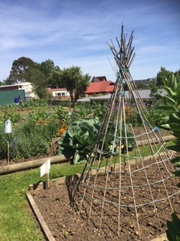 | 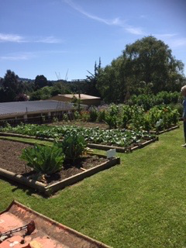 | 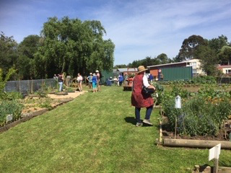

The Community Garden is selling surplus seedlings at the Green Island Christmas Market
on the coming Saturday 7th December from 10am -1 pm.

Kindred Day – 4 April 2020 – by Helen Flockton

Following the wonderful day at the Kakanui Kindred day last month we now have a much better idea of how the day runs and what will be needed.
Margaret will talk at our next meeting and explain in more detail but there are 3 important aspects for you to consider and put on your calendars.
- we will need HELPERS on Friday evening 3rd April to set up the hall and plant stall and again on Saturday 4th April to ensure the smooth running of the day.
- PLANTS for sale and for the raffles please add a few extra seeds when planting for the vegetable baskets.
- FOOD for morning and afternoon teas

DVGC Subscriptions for 2020 – are now due.

The amount is $15.- if paid before 31th March, thereafter $20.-. If you prefer to be sent a paper copy add another $ 5.-. Please pay by cash at the desk or into the above DVGC bank acc. No. - and don’t forget to put your name as reference.

Address changes

If you have recently changed your contact details, address or phone numbers, please let Helen Flockton know at the desk or by email, thanks.

